March 25, 2025
VALID:
3/25/25 – 12/31/25

SPORTING NOTE # 1
Please note the following amendments to the 2025 Pirelli GT4 America Sporting Regulations:
SR 42.20 has been amended to read as follows:
- Any Driver causing a stoppage and/or red flag during qualifying will lose his 2 (two) fastest qualifying lap times for that session. The Driver causing the Red Flag will be prohibited from further participation in that Qualifying session. Any car(s) involved in a simultaneous or concurrent incident will be reviewed by the Stewards and is subject to penalty.
SR 28.7 has been amended to read as follows:
- 28.7 The minimum average weight of the Drivers (DA) in any car competing in the Series is 90 (ninety) kilograms (kg) and is not included in the minimum BoP weight of the car. Should the average weight of the Drivers in any specific car be less than 90 kg, the car must carry Driver Ballast to compensate. The following procedure will be followed:

- Each Competitor must weigh their Drivers, including fire suit, underwear, shoes, gloves, helmet, and FHR device, at the time of the administrative checks
- The average weight of the Drivers in the car will be calculated and rounded up to the nearest integer (DA)
- If DA < 90, then the Driver Ballast to be carried by the car will be 90–DA
- The Driver Ballast must be installed in the ballast box and sealed before qualifying
- The Driver Ballast, as well as the individual weight of the Drivers in question, may be checked at any point during the event.
- For cars competing in the AM or PRO-AM category of the Series only, if DA>90, then the weight of DA-90, up to a maximum of 5 kg, may be removed from the minimum BOP weight of the car.

AM / PRO-AM  DA | Maximum amount that can be removed from Minimum BOP weight
90 kg | 0 kg
91 kg | 1 kg
92 kg | 2 kg
93 kg | 3 kg
94 kg | 4 kg
95 kg | 5 kg
96 + kg | 5kg

- Competitors using the same chassis number in both GT World Challenge America and GT America are exempt from sealing ballast. The Competitor must be compliant with the BOP weight.
- All Ballast must be installed in accordance with the applicable Technical Regulations.

Greg Gill  President | Jacquie Groom  Sporting Director | BRIAN Till  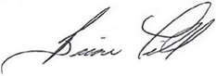  Race Director | Scot Elkins  Chairman of the Stewards
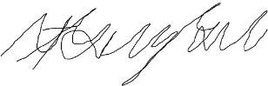 | 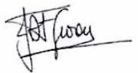
Joe Legan  Technical | Staci Langham  Series GM | Jason Smith  President - USAC
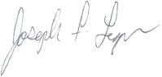 | 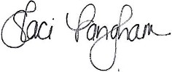 | 

